Test Case: tc002_SPX_Dev5_Crear_Requisicion_Spot_Tipo_Cobro_Project
Step 1 - Enter username and password and click to button Enter: Credentials Entered
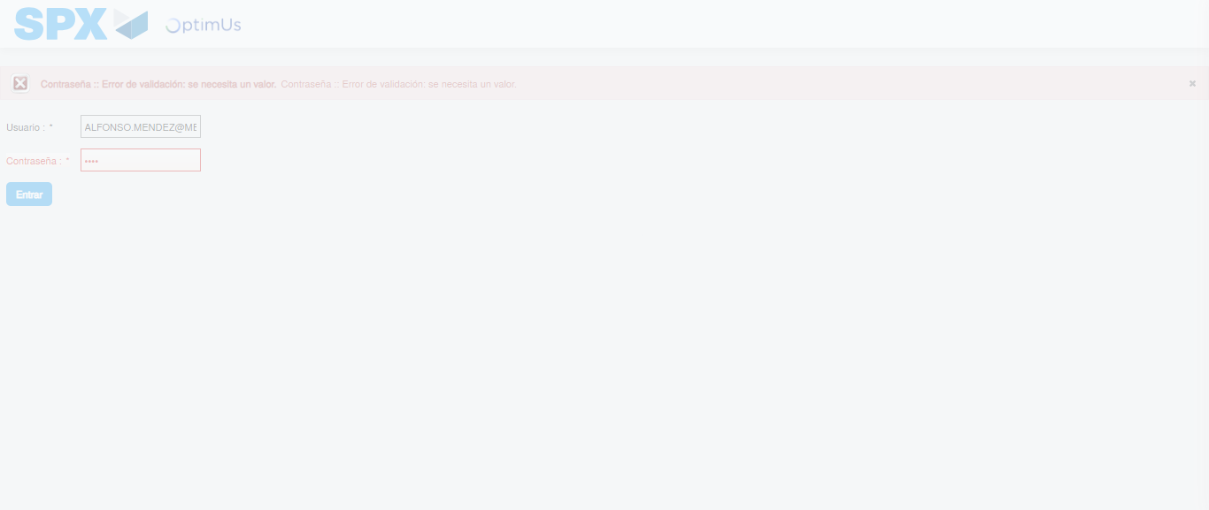Image file-name: QC_Testing-tc002_SPX_Dev5_Crear_Requisicion_Spot_Tipo_Cobro_Project-1783382084252

Step 2 - Select to UEN and Access to Spot Buy Requisitions : UEN Correctly selected and Correct access
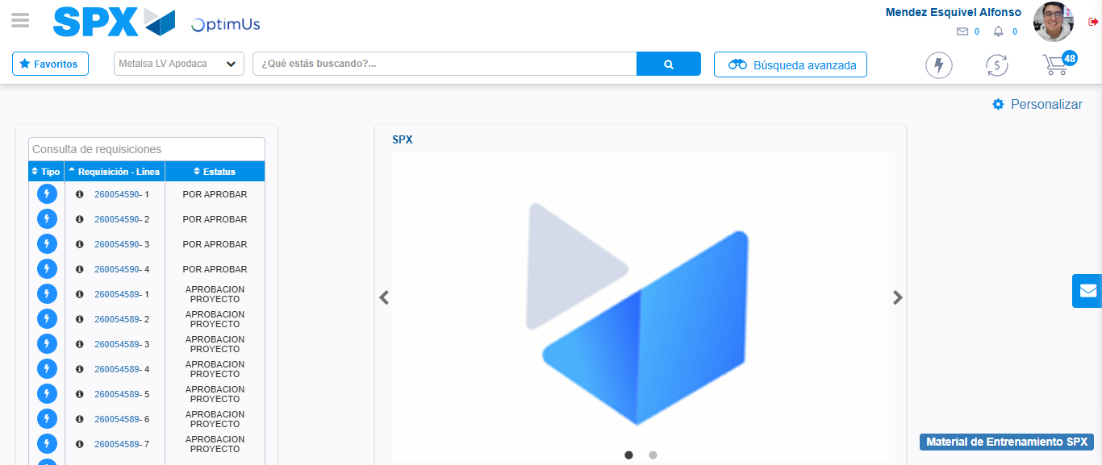Image file-name: QC_Testing-tc002_SPX_Dev5_Crear_Requisicion_Spot_Tipo_Cobro_Project-1783382110320

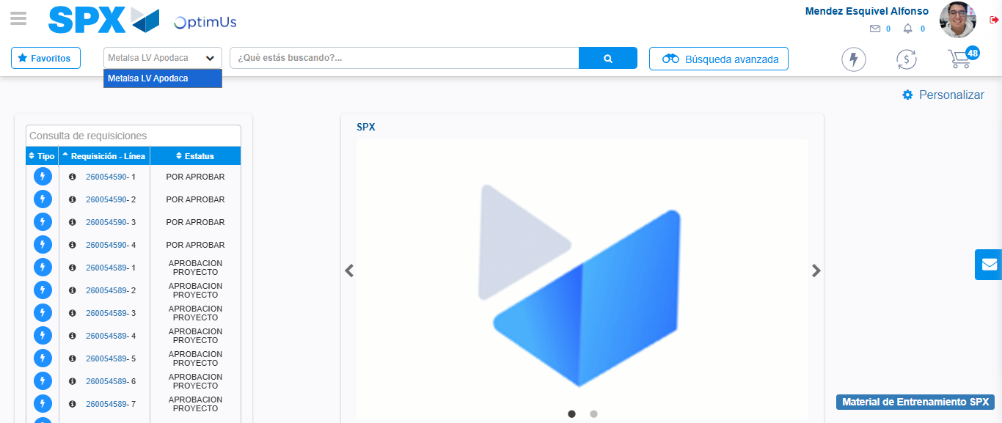Image file-name: QC_Testing-tc002_SPX_Dev5_Crear_Requisicion_Spot_Tipo_Cobro_Project-1783382112768

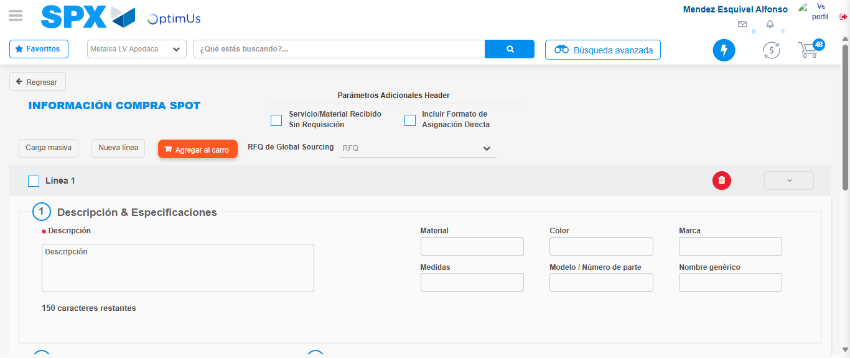Image file-name: QC_Testing-tc002_SPX_Dev5_Crear_Requisicion_Spot_Tipo_Cobro_Project-1783382133705

Step 3 - Data Capture Spot Buy Requisition: Data captured correctly
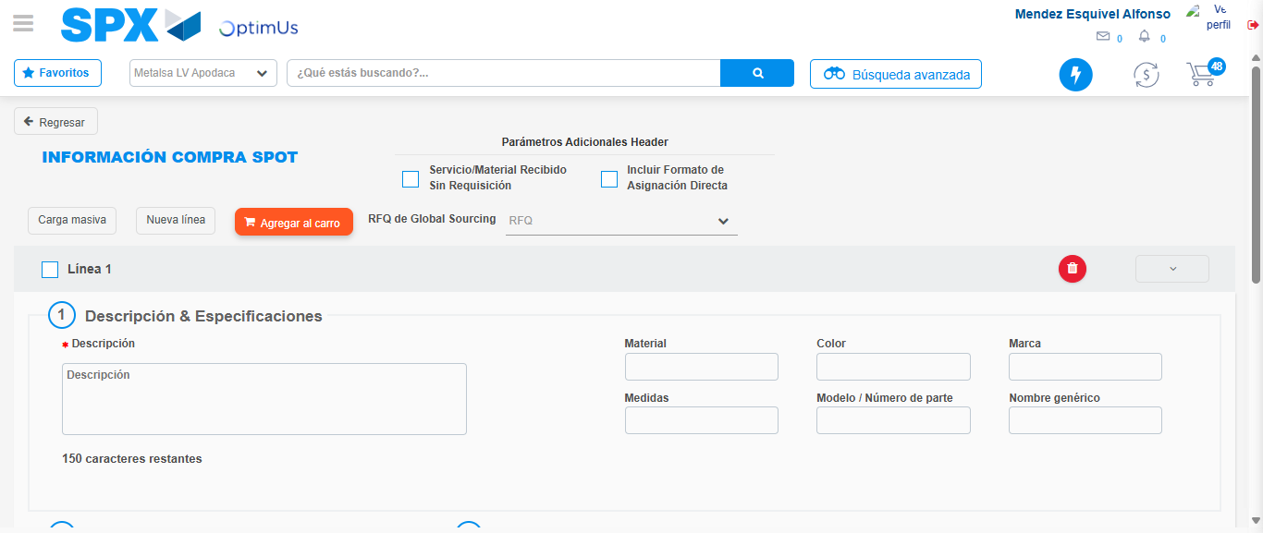Image file-name: QC_Testing-tc002_SPX_Dev5_Crear_Requisicion_Spot_Tipo_Cobro_Project-1783382133984

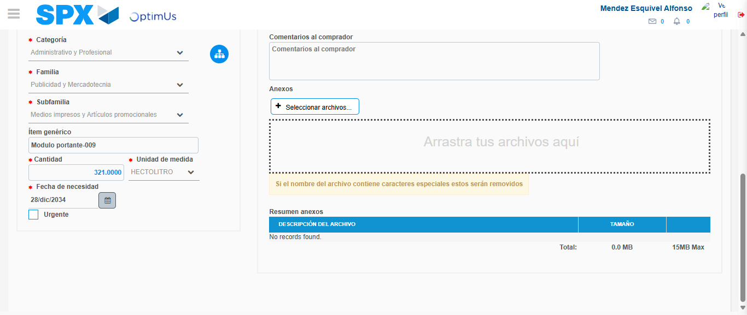Image file-name: QC_Testing-tc002_SPX_Dev5_Crear_Requisicion_Spot_Tipo_Cobro_Project-1783382143565

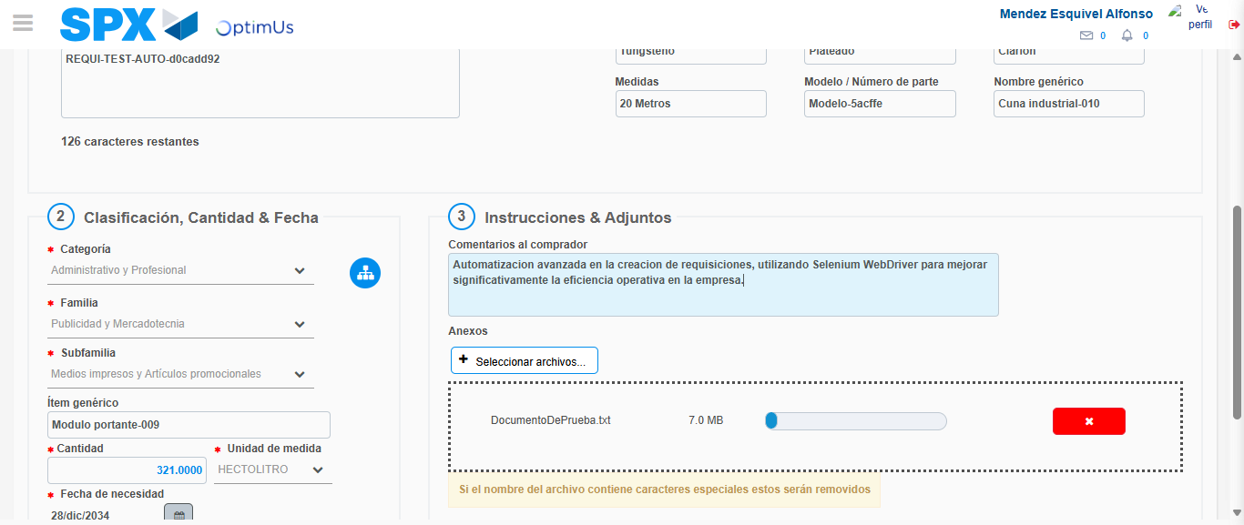Image file-name: QC_Testing-tc002_SPX_Dev5_Crear_Requisicion_Spot_Tipo_Cobro_Project-1783382144292

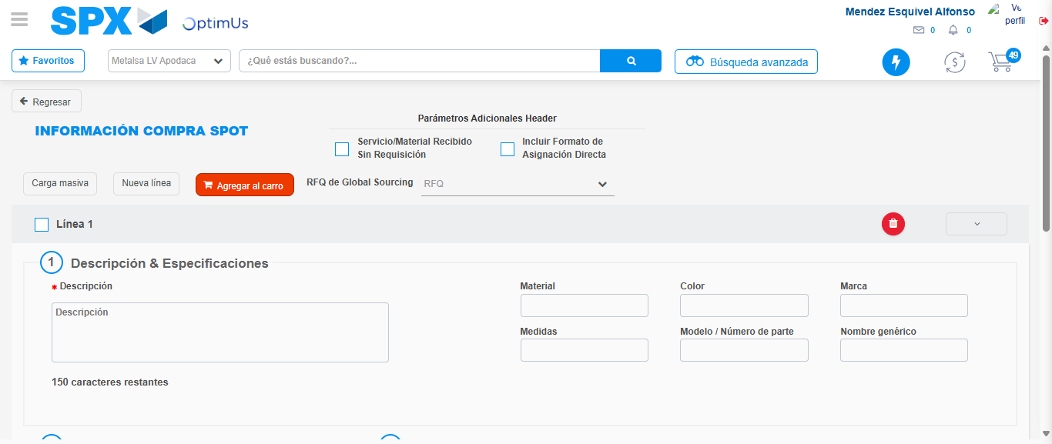Image file-name: QC_Testing-tc002_SPX_Dev5_Crear_Requisicion_Spot_Tipo_Cobro_Project-1783382151767

Step 7 - Return to Main Page SPX : Return to Main Page SPX
Image file-name: QC_Testing-tc002_SPX_Dev5_Crear_Requisicion_Spot_Tipo_Cobro_Project-1783382110320

Image file-name: QC_Testing-tc002_SPX_Dev5_Crear_Requisicion_Spot_Tipo_Cobro_Project-1783382112768

Image file-name: QC_Testing-tc002_SPX_Dev5_Crear_Requisicion_Spot_Tipo_Cobro_Project-1783382133705

Image file-name: QC_Testing-tc002_SPX_Dev5_Crear_Requisicion_Spot_Tipo_Cobro_Project-1783382154019

Image file-name: QC_Testing-tc002_SPX_Dev5_Crear_Requisicion_Spot_Tipo_Cobro_Project-1783382154183

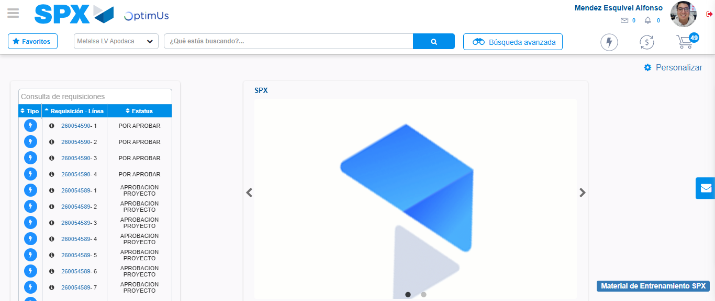Image file-name: QC_Testing-tc002_SPX_Dev5_Crear_Requisicion_Spot_Tipo_Cobro_Project-1783382175295

Step 8 - Log Out : Log Out SPX
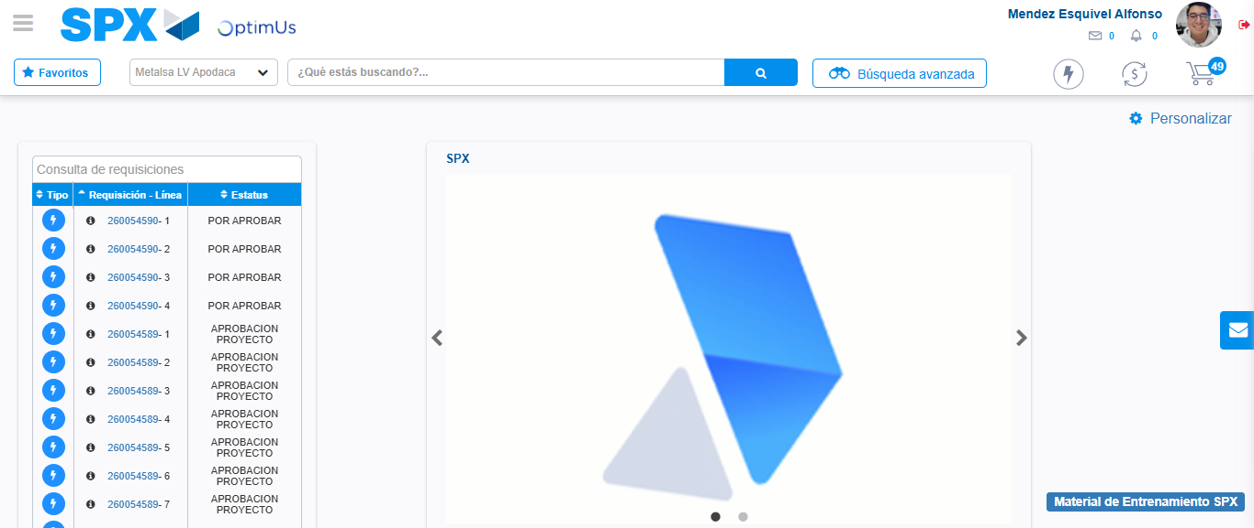Image file-name: QC_Testing-tc002_SPX_Dev5_Crear_Requisicion_Spot_Tipo_Cobro_Project-1783382175541

